Addison Babcock, 200013782

Instructor: Dario Medele

October 28th, 2015

Golf course manager

Inception Document

Table of Contents

Vision for Golf Course Manager 4

Stakeholders 4

Proposed Solution 4

Actors 4

Glossary 6

Golf Course Manager 6

Club BAIST Clubhouse Staff 6

Club BAIST Front Office Staff 6

Club BAIST Management 6

Club BAIST Finance Committee 6

Club BAIST Membership Committee 6

Club BAIST Board of Directors 6

Club BAIST Members 6

Time Slot 6

Membership Level 6

User 6

Use Case Specifications 7

Use Case Model 7

Use Case Descriptions 8

Create Reservation 8

View/Update/Cancel Reservation 8

View Membership Status and Details 8

View Daily List of Reservations 8

Update Membership 8

Schedule Tournaments 8

Create and Update Membership Levels and Pricing 8

View Membership Reports 8

View Available Reservation Slots 9

Apply Discounts 9

Supplementary Specifications 10

Functional 10

Features 10

Security 10

Usability 10

Human factors 10

Help 10

Documentation 10

Reliability 10

Frequency of failure 10

Recoverability 10

Performance 10

Response times 10

Throughput 10

Accuracy 10

Availability 11

Resource usage 11

Supportability 11

Adaptability 11

Maintainability 11

Internationalization 11

Configurability 11

Implementation 11

Resource limitations 11

Languages and tools 11

Hardware 11

Interface 11

Operations 11

Packaging 11

Legal 12

Architectural Factors 12

Factor 12

Measures and quality scenarios 12

Variability (current flexibility and future evolution) 12

Risk List 13

Iteration Plan 14

Business Bid 14

Project Schedule 14

Project Plan 14

Return On Investment 15

Stakeholder Benefits 15

Software Architecture Document 16

Architectural Representation 16

# Vision for Golf Course Manager

Currently the reservation and member management system for Club BAIST is manual and paper based. Club BAIST members call in to the office in order to make or cancel a reservation. This can be problematic if the office staff are busy as there is a penalty to members who do not use their reservations. Club BAIST would like to provide its members with a website that will allow them to create and manage reservations without having to call in.

## Stakeholders

The stakeholders for this project include the Club BAIST clubhouse staff, the Club BAIST front office staff, Club BAIST management, the Club BAIST members, the Club BAIST Finance Committee, the Club BAIST Membership Committee as well as the Club BAIST board of directors.

The Club BAIST clubhouse staff needs to be able to review a daily list of reservations and indicate whether the Club BAIST Members have played their reservation.

The Club BAIST front office staff needs to be able to book and cancel reservations. They also need to be able to review applications and inform Club BAIST members about the application and account status. Club BAIST front office staff need to be able to accept payments for memberships.

The Club BAIST management need to be able to provide discounts as well as cancel memberships. The Club BAIST management also needs to be able to override the reservation system and set up tournament booking.

The Club BAIST Finance Committee needs to be able to be able to update the membership levels and annual pricing. The Club BAIST Finance Committee also needs to be able to track each Club BAIST Members account and their activity at the club.

The Club BAIST Membership Committee needs to be able to be able to update the membership levels and pull reports on memberships and their statuses. The Club BAIST Membership Committee needs to be able to review and approve membership applications.

The Club BAIST Board of Directors needs to be able to be able to pull reports, including lists of memberships and their statuses. They also need to be kept up to date on the progress of this project.

## Proposed Solution

The solution will be built as an external and internal facing website with an N-tier architecture backed by a database. The website will need to be mobile friendly to allow for easy reservations by the Club BAIST Members.

## Actors

Club BAIST Members – Add and cancel reservations. Apply for new reservations and vouch for new membership applications. Pay for membership fees. Change membership level. View membership status. View their reservations.

Club BAIST Clubhouse Staff – Review a daily list of reservations. Indicate whether the reservation was used.

Club BAIST Front Office Staff – Book and cancel reservations. Review applications. Accept payments for reservations.

Club BAIST Management – Provide discounts, cancel memberships, override reservation system, and set up tournament booking.

Club BAIST Finance Committee – Update membership levels and annual pricing. Track each members account and activity.

Club BAIST Membership Committee – Update membership levels, pulls reports on memberships and their status. Review and approve membership applications.

Club BAIST Board of Directors – Pull reports on memberships.

# Glossary

## Golf Course Manager

The software being built in this project.

## Club BAIST Clubhouse Staff

The group of staff who are stationed at the first hole. They are responsible for allowing players to tee off and verifying that they have a reservation. They also take note of when Club BAIST Members show or don’t show for a reservation.

## Club BAIST Front Office Staff

The group of staff who are stationed inside the office. They are responsible for answering phones and for creating and cancelling reservations. They need to be able to inform Club BAIST Members of their application, financial, and reservation status.

## Club BAIST Management

The group of staff who manage day to day operations at Club BAIST. They are able to set up special events and override the reservation system in case of conflicts. They are also able to provide discounts.

## Club BAIST Finance Committee

The Club BAIST Finance Committee is able to view reports of Club BAIST Members and their payment status. The Club BAIST Finance Committee is composed of staff who might also be a part of other groups.

## Club BAIST Membership Committee

The Club BAIST Membership Committee is responsible for approving new memberships. The Club BAIST Membership Committee is composed of staff who might also be a part of other groups.

## Club BAIST Board of Directors

## Club BAIST Members

This is the group of people who have at minimum a membership application in the system.

## Time Slot

A time slot is a tee off time which is available to be booked or is already booked. These can be occupied by members or by tournaments or they can be empty.

## Membership Level

The system will support different membership levels. A higher Membership Level can bump the reservations of Club BAIST Members with lower Membership Levels.

## User

A user is an individual person using the system. This person might not be authenticated and can have any level of authorization.

# Use Case Specifications

## Use Case Model

Golf Course Manager

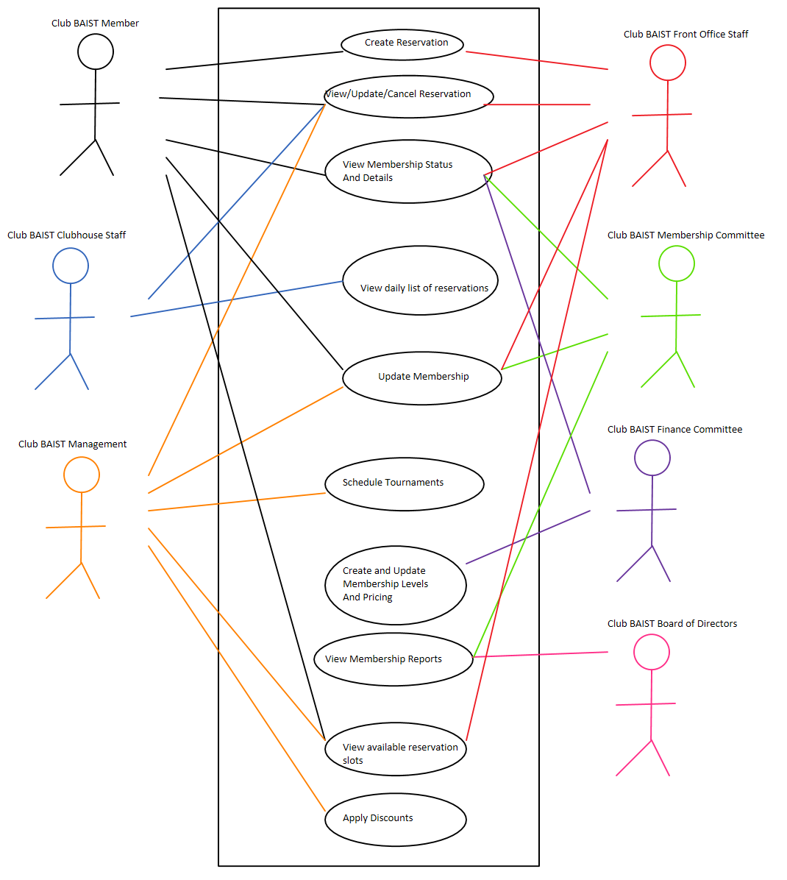

## Use Case Descriptions

### Create Reservation

The Club BAIST Member wishes to reserve a tee time for themselves and up to 3 other people. The desired time slot must be available and the Club BAIST Member must be in good standing. The desired time slot must be for a future date (same day is not allowed). If successful, the system will mark that time slot as reserved by the Club BAIST Member. This use case will also be available to Club BAIST Front Office Staff who can create reservations for Club BAIST Members who call in over the phone or who are in the office. This use case will need to be able to create a recurring standing reservation.

### View/Update/Cancel Reservation

The Club BAIST Member wishes to view or cancel or update their current reservation. Cancelling or changing the time of a reservation will free up that time slot for use by other Club BAIST Members. Club BAIST Clubhouse Staff will be able to mark the reservation as fulfilled when the Club BAIST Member tees off on time. Club BAIST Front Office Staff will be able to use this use case on behalf of Club BAIST Members. Club BAIST Management will be able to use this use case when needed.

### View Membership Status and Details

The Club BAIST Members will be able to review their membership status and their demographic information. This will allow them to view important details like whether their applications have been approved, payments have been accepted, and so on.

### View Daily List of Reservations

The Club BAIST Clubhouse Staff need to be able to print a list of the days’ time slots. They will mark each reservation as fulfilled as the Club BAIST Member tees off. This list should have the Club BAIST Members and their party’s names.

### Update Membership

Club BAIST Members and Club BAIST Front Office Staff will be able to update their contact and demographic information as well as change the Club BAIST Members level through this use case. The Club BAIST Membership Committee and Club BAIST Management will use this use case to approve and cancel memberships.

### Schedule Tournaments

Club BAIST Management needs to be able to create large blocks of reservations easily for tournaments. If a time slot is already occupied by a prior reservation that reservation will be automatically cancelled.

### Create and Update Membership Levels and Pricing

The system needs to be flexible enough to accommodate changes to the membership levels and their pricing. This use case will be available to the Club BAIST Finance Committee. The updated membership levels and pricing will be reflected on the next invoice for Club BAIST Members.

### View Membership Reports

The Club BAIST Finance Committee and the Club BAIST Board of Directors need to be able to review how the Club BAIST Golf Club is performing. What reports are required have not been determined yet but will likely include monthly approved memberships, monthly total memberships broken down by Membership Level and Club BAIST Members who have not paid their dues.

### View Available Reservation Slots

Club BAIST Members, Club BAIST Front Office Staff and Club BAIST Management need to be able to view the available Time Slots for a given day. From there the person using this use case will be able to create a reservation. If a Time Slot is currently reserved by a Club BAIST Member with a lower Membership Level than the Club BAIST Member using the use case, that Time Slot will be shown as available. If Club BAIST Management is using this use case, the reserved Time Slots will show the name of the Club BAIST Member who has reserved that Time Slot.

### Apply Discounts

Club BAIST Management needs to be able to apply discounts to in case of Club BAIST Member complaints. The discounts will only apply to membership fees.

# Supplementary Specifications

## Functional

### Features

* Log authentication errors to persistent storage.
* Log reservation activity.
* Notify Club BAIST Members if their reservation gets bumped.

### Security

* Authentication will be required before any functionality is usable.
* Different use cases will be enabled depending on the capabilities the user has. A user might belong to multiple authorization groups.

## Usability

### Human factors

* The interface will need to be usable as a desktop website and a mobile website.
* The website will be public facing so be careful of unnecessary jargon.

### Help

* Support for this software will be provided by us during regular business hours.

### Documentation

* Documentation will be supplied for all user facing functionality.

## Reliability

### Frequency of failure

* The system is critical to the success of Club BAIST. We will aim for 99.9% reliability (8.8 hours downtime per year).

### Recoverability

* We will be making daily incremental backups in addition to weekly full backups. We will build the system to allow for server side redundancy.

## Performance

### Response times

* The system should spend less than 50 milliseconds building the majority of pages. Network response might vary but should be less than 10 milliseconds on the local network.

### Throughput

* The system should be able to handle up to 20 simultaneous users.

### Accuracy

* Accuracy should generally not be an issue.

### Availability

* Because the Club BAIST offices are in a remote location the software will be hosted in the cloud. An internet connection to the site might not be reliable but the Golf Course Manager software will continue to be available to Club BAIST Members.

### Resource usage

* Resource usage should be in line with similar small e-commerce sites.

## Supportability

### Adaptability

* We should consider building this software to allow for multiple golf courses running on the same software.

### Maintainability

### Internationalization

* No internationalization is required for this application. It will be written in Canadian English.

### Configurability

* The Time Slots need to be configurable. The Membership Levels need to be configurable. Tax rates need to be configurable.

## Implementation

### Resource limitations

* Because the web pages will be mobile-friendly they should be written to not consume excessive bandwidth.

### Languages and tools

* The software will be written in ASP.Net using C# with SQL backend.

### Hardware

* We will need to install POS computers, networking and printers in the Club BAIST office. The server software will run in the cloud to save on hardware costs and minimize the dependency of Club BAIST on an internet connection.

## Interface

* The interface needs to be responsive to the user’s device.

## Operations

* The system does not currently require significant operator oversight. We will need to ensure that backups run correctly.

## Packaging

* This software will not be physically packaged.

## Legal

* The software will be developed for and licensed to a single client, Club BAIST. We will maintain ownership of the source code so we can license it to other clients should the need arise.

## Architectural Factors

### Factor

* The software needs to respond quickly to user requests.
* The software needs to be themed in case we want to license it to other golf courses.

### Measures and quality scenarios

* The software will be considered high quality if:
* Low response times.
* Low support calls.
* Majority of Club BAIST Members using the software.
* Club BAIST Members can easily and quickly create reservations.

### Variability (current flexibility and future evolution)

* The current system will be flexible enough to allow for changes to the Club BAIST hours and tee-off frequency. The current system will be flexible enough to allow for changes to the Membership Levels and pricing.
* In the future the system should be flexible enough to allow for multiple golf courses.

# Risk List

|  |  |  |
| --- | --- | --- |
| Ranking | Use Case | Reason |
| High | Create Reservation | This use case is critical to the system. The algorithm to bump Club BAIST Members with lower Membership Levels might be tricky. |
| High | View/Update/Cancel Reservation | Updating a reservation might need to bump a reservation similar to the Create Reservation use case. If a Time Slot is freed up that was previously bumped the system might need to inform the other Club BAIST Member. |
| High | Schedule Tournament | This use case needs to be able to bump reservations when a reservation conflicts with a tournament. |
| Medium | Create and Update Membership Levels and Pricing | There is a lot of complexity involved in this use case however it’s likely to be used rarely. |
| Medium | Update Membership | Differently authorized users will be able to do different things here. |
| Medium | View Available Reservation Slots | There is some business logic involved in this use case and it links to other use cases. |
| Medium | Apply Discounts | We need to be able to account for discounts from Club BAIST Management. |
| Low | View Membership Status and Details | A fairly simple use case, only involves retrieving and displaying information. |
| Low | View Daily List of Reservations | A fairly simple use case, only involves retrieving and displaying information. |
| Low | View Membership Reports | The type of reports being generated will likely not have a significant architectural impact. They will also be run rarely. |

# Iteration Plan

Phase: Elaboration

Iteration: 1

|  |  |  |  |  |
| --- | --- | --- | --- | --- |
| Core Workflow Discipline | Use Case | Activity | Time | Resources |
| Analysis / Design | Create Membership | Use case analysis, fully dressed | 8 hours | Business Analyst |
| Analysis / Design | Update Membership | Use case analysis, fully dressed | 12 hours | Business Analyst |
| Analysis / Design | Create Reservation | Use case analysis, fully dressed | 12 hours | Business Analyst |
| Analysis / Design | View / Update / Cancel Reservation | Use case analysis, fully dressed | 16 hours | Business Analyst |
| Analysis / Design | View Daily List of Reservations | Use case analysis, fully dressed | 12 hours | Business Analyst |
| Analysis / Design | Schedule Tournaments | Use case analysis, fully dressed | 16 hours | Business Analyst |
| Architecture Design | Pick cloud provider | Get pricing from major cloud service providers | 8 hours | Architect |
| Database Design | Create schema | Create major database tables | 24 hours | DBA |
| Construction | Create source code repository | Source control | 4 hours | Lead Developer |
| Screen layout | Screen layouts | Mock up major screen layouts | 40 hours | Designer |

# Business Bid

## Project Schedule

Phase: Elaboration

|  |  |  |  |  |
| --- | --- | --- | --- | --- |
| Iteration | Minor Milestone | Start Date | End Date | Resources |
| 1 | Major use cases designed | January 1, 2016 | January 31, 2016 | Business Analyst (2)  Architect  DBA  Lead Developer  Designer |
| 2 | Data model completed | February 1, 2016 | February 29, 2016 | Business Analyst (2)  Architect  DBA (2)  Lead Developer  Designer |

# Project Plan

Phase: Elaboration

Number of Iterations: 2

Start Date: January 1, 2016

End Date: February 29, 2016

Resources: Business Analyst (2), Architect, DBA (2), Lead Developer, Designer

Hours: 300

# Return On Investment

* Reduced penalties for Club BAIST Members missing tee times.
* Higher course usage because there will be fewer missed tee times.
* Reduced time spent by Club BAIST Front Office Staff dealing with reservations.
* Easily compile and generate reports for Club BAIST Management.
* Club BAIST Members can quickly and easily reserve a tee time.

# Stakeholder Benefits

|  |  |
| --- | --- |
| Stakeholder | Benefits |
| Club BAIST Clubhouse Staff | * Easier tracking off no shows * Quickly view the daily list of reservations |
| Club BAIST Front Office Staff | * Reduced workload booking and cancelling reservations * Reduced workload updating Club BAIST Member information * Reduced workload informing Club BAIST Members of their status |
| Club BAIST Management | * Quickly generate reports * Quickly cancel problem Club BAIST Memberships * Easily set up tournament schedules |
| Club BAIST Members | * Instantly create and cancel reservations * Easily check if a time slot is available * No waiting on the phone to check on membership status |
| Club BAIST Finance Committee | * Quickly generate reports * Easily update Membership Levels * Track Club BAIST Member activity |
| Club BAIST Membership Committee | * Easily update Membership Levels * Track Club BAIST Member activity * Quickly generate reports |
| Club BAIST Board of Directors | * View financial activity of Club BAIST Members * Generate reports |

# Software Architecture Document

## Architectural Representation

|  |  |  |  |  |  |
| --- | --- | --- | --- | --- | --- |
| Factor | Measures and quality scenarios | Variability (current flexibility and future evolution) | Impact of factor (and its variability) on stakeholders, architecture, and other factors | Priority for success | Difficulty or risk |
| Reliability | High reliability for Club BAIST Members | The system will be deployed to the cloud | Low impact to stakeholders | High | Medium |
| Licensability | Front end is easily themed | The system will only be built for one client at first | Medium impact to architecture | Medium | Medium |
| Mobile responsive | Front end adapts well to mobile devices | The system will be built with mobile devices in ind | High impact to architecture and stakeholders | High | Medium |